Ethical approval
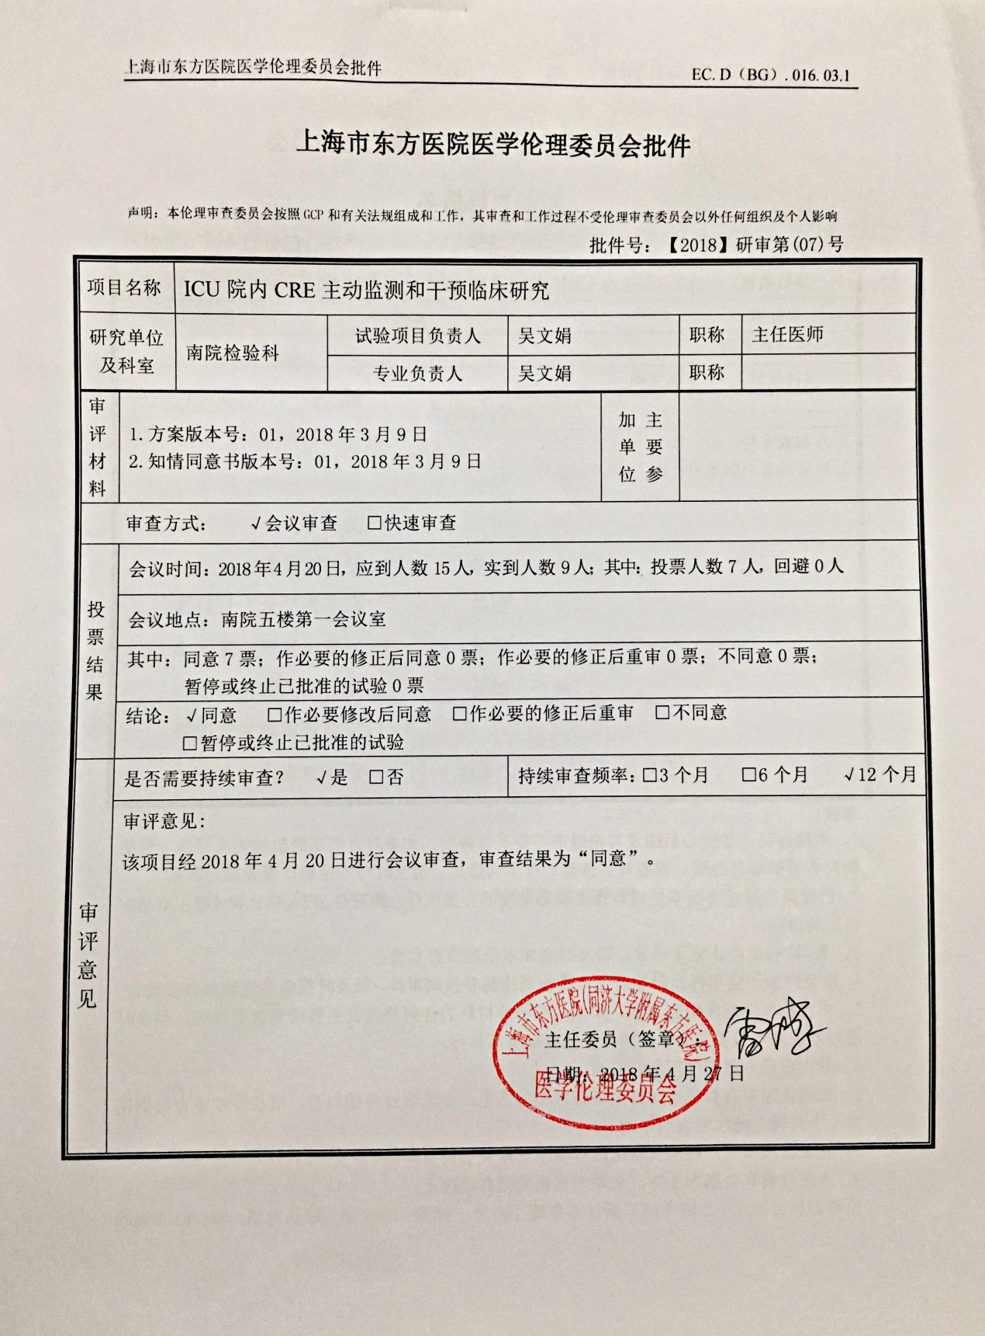English Version:
Shanghai East Hospital(Tongji University School of Medicine)
Approval No.:【2018】(07)
Project name | Active rapid molecular screening and infection-prevention and control interventions to reduce spread of Carbapenem-Resistant Enterobacteriaceae in emergency intensive care unit
Research institution and department | Shanghai East Hospital, Department of clinical laboratory | Project leader | Wenjuan Wu |  | Professional title |  | Professor
Research institution and department | Shanghai East Hospital, Department of clinical laboratory | Major leader | Wenjuan Wu |  | Professional title |  | Professor
Review material | Clinical research protocol version：01, 2018/3/9  Informed consent version：01, 2018/3/9 |  |  |  | Main participants
Method of review：Conference review
Voting result | Meeting date: 2018/4/20
Voting result | Meeting Place: Conference Room I in Shanghai East Hospital
Voting result | Result: Unanimous consent
Voting result | Conclusion: Agreement
Review opinions | Whether continuous review is needed:Yes |  |  | Continuous review frequency: 12 month
Review opinions | Review comments: the project was reviewed by the meeting on April 20, 2019 and we agreed to apply for the project.
The address of ethics committee: No. 150 Jimo Road, Pudong New district, Shanghai Code:200120 Phone number: 021-61569829

